**Aim**

To model a simple HTML file describing your hometown (demonstrate the use of tags).

**Program Code**

<html>

<head>

<title>

My Home Town

</title>

<link rel="icon" type="image/x-icon" href="https://e7.pngegg.com/pngimages/48/511/png-clipart-computer-icons-home-home-angle-text-thumbnail.png">

</head>

<body>

<div>

<h1>KOCHI......</h1><h3> A GOOD DESTINATION OF LOVE!!</h3>

</div>

<div>

<p>Kochi, also known as Cochin is the biggest city in the state of Kerala. This city is being used as a part and the gateway to India since the 14th century, and is one of the best places in South India. To explore and see the best tourist places in Kochi, steep in the rich glorious history, nurtured by the foreign powers like Arabs, Portuguese, Chinese, British, and Dutch for centuries, it’s a must visit city for those who want to learn about the rich history of the country as the Colonial India and its trading prowess during the earlier times.</p>

<p>A flood somewhere in the 1300s carved out the harbor of the Kochi, and since 1341 it’s being used as a port by the European, Chinese and Arab merchants. There is an array of historical sites which reflect the influence of these international traders on the city.</p>

<p>Kochi is one of the best places that are ideal for both, a family holiday and a romantic honeymoon. The houseboats and boating in the tranquil backwaters make visiting Kochi an experience of the lifetime. Also, if you love Ayurveda and Yoga, and want to dig deeper in it, there are many Ayurvedic centers and resorts in the city that can be visited.

</p>

</div>

</body>

</html>

**Output**

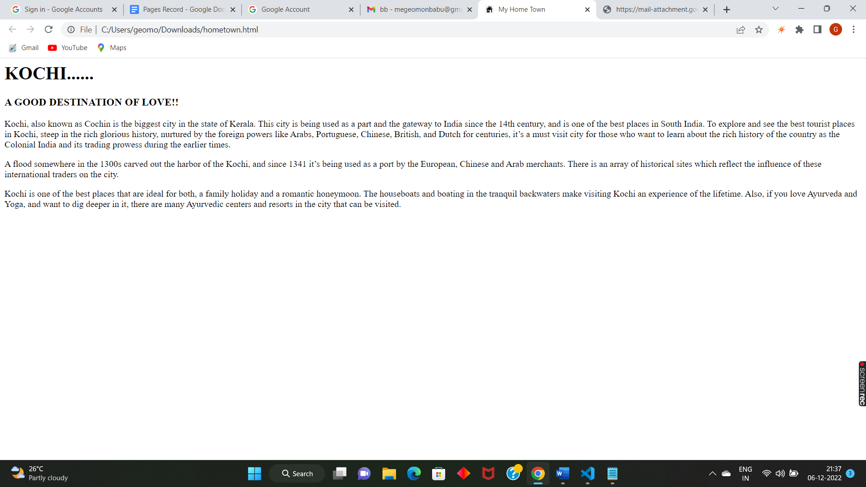

**Aim**

To create a webpage for displaying your biodata which contains image tables and a link within a page.

**Program Code:**

**Biodata.html**

<html>

<head>

<title>

Home Page

</title>

<link rel="icon" type="image/x-icon" href="https://img.favpng.com/11/11/0/favicon-icon-

design-icon-png-favpng-sduUigdJeetAFzLEV85GzhBeU.jpg">

<style>

body {

background-color: deepskyblue;

}

img {

width: 350px;

float: left;

margin-right: 10px;

}

table, th, td {

margin-left: auto;

margin-right: auto;

border: 1px solid black;

border-collapse: collapse;

}

</style>

</head>

<body>

<div>

<br><br><br><br>

<img src="https://files.myglamm.com/site-images/original/no-user-yellow.png" alt="Girl

in a jacket" width="200" height="250">

<br><br><br><br>

<p>Ryan Davis is a Brand and Marketing Strategist who works towards the

upliftment of several personal and professional brands. Ryan holds a Bachelor’s degree in

communication from the University of Texas. He understands that the only way a brand

can succeed is by truly connecting with the people. Ryan has worked with esteemed

companies such as CNN and Edelman. The extensive PR and marketing experience that

Ryan possesses makes him a highly known name in the industry. Ryan is also a certified

business coach who likes to spend his Time telling people about business basics.</p>

<p>Joe Tucker published his first book ‘ Time,’ when he was 20. He has since

then been involved in writing columns for various newspapers and magazines. Joe

graduated from Columbia University and took up writing as a career to be able to bring the

world together with the power of his words. He is currently working on a non-fiction novel

that speaks about his life experiences. His works have been critically acclaimed, and he

was awarded the National Prize for Arts in the year 2019.</p>

</div>

<div>

<table>

<tr>

<th>Personal Details</th>

<th>Academic Details</th>

</tr>

<tr>

<td>John Luker</td>

<td>B.tech </td>

</tr>

<tr>

<td>Born in Netherland</td>

<td>Best outgoing Student of the year</td>

</tr>

<tr>

<td><a href="personal.html" style="text-decoration:none">Read More...</a></td>

<td><a href="academic.html" style="text-decoration:none">Read More...</a></td>

</tr>

</div>

</body

</html>

**Personal.html**

<html>

<head>

<title>

Personal Details

</title>

<link rel="icon" type="image/x-icon" href="https://img.favpng.com/11/11/0/favicon-icon-

design-icon-png-favpng-sduUigdJeetAFzLEV85GzhBeU.jpg">

<style>

body {

background-color: MediumSeaGreen;

}

table, th, td {

margin-left: auto;

margin-right: auto;

border: 1px solid black;

border-collapse: collapse;

}

</style>

</head>

<body>

<table>

<tr>

<th>Full Name</th>

<td>John Luker</td>

</tr>

<tr>

<th>Location</th>

<td>Netherland</td>

</tr>

<tr>

<th>Contact details</th>

<td>9478521423,abc@gmail.com</td>

</tr>

<tr>

<th>Father's Name</th>

<td>Xavier John</td>

</tr>

<tr>

<th>Mother's Name</th>

<td>Andria John</td>

</tr>

<tr>

<td><a href="biodata.html" style="text-decoration:none">Home Page</a></td>

<td><a href="academic.html" style="text-decoration:none">Academic Details</a>

</td>

</tr>

</table>

</body>

</html>

**Academic.html**

<html>

<head>

<title>

Academic Details

</title>

<link rel="icon" type="image/x-icon" href="https://img.favpng.com/11/11/0/favicon-icon-

design-icon-png-favpng-sduUigdJeetAFzLEV85GzhBeU.jpg">

<style>

body {

background-color: #bfff00;

}

table, th, td {

margin-left: auto;

margin-right: auto;

border: 1px solid black;

border-collapse: collapse;

}

</style>

</head>

<body>

<table>

<tr>

<th>Graduation</th>

<td>B.Tech</td>

<td>70.2</td>

</tr>

<tr>

<th>12th</th>

<td>Science</td>

<td>73.3</td>

</tr>

<tr>

<th>10th</th>

<td>State syllabus</td>

<td>86.56</td>

</tr>

<tr>

<td><a href="biodata.html" style="text-decoration:none">Home Page</a></td>

<td><a href="personal.html" style="text-decoration:none">Personal Details</a></td>

</tr>

**Output**

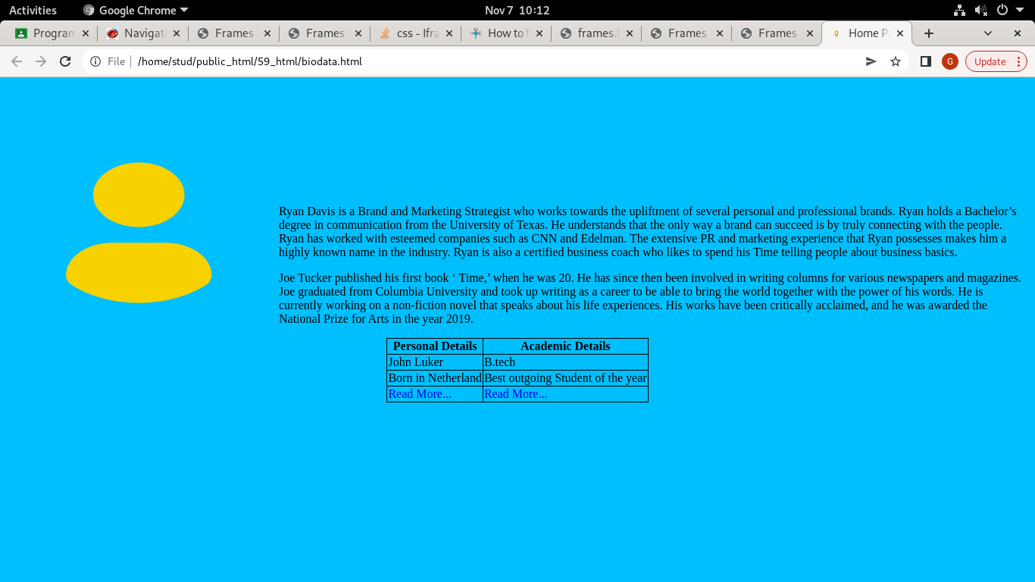

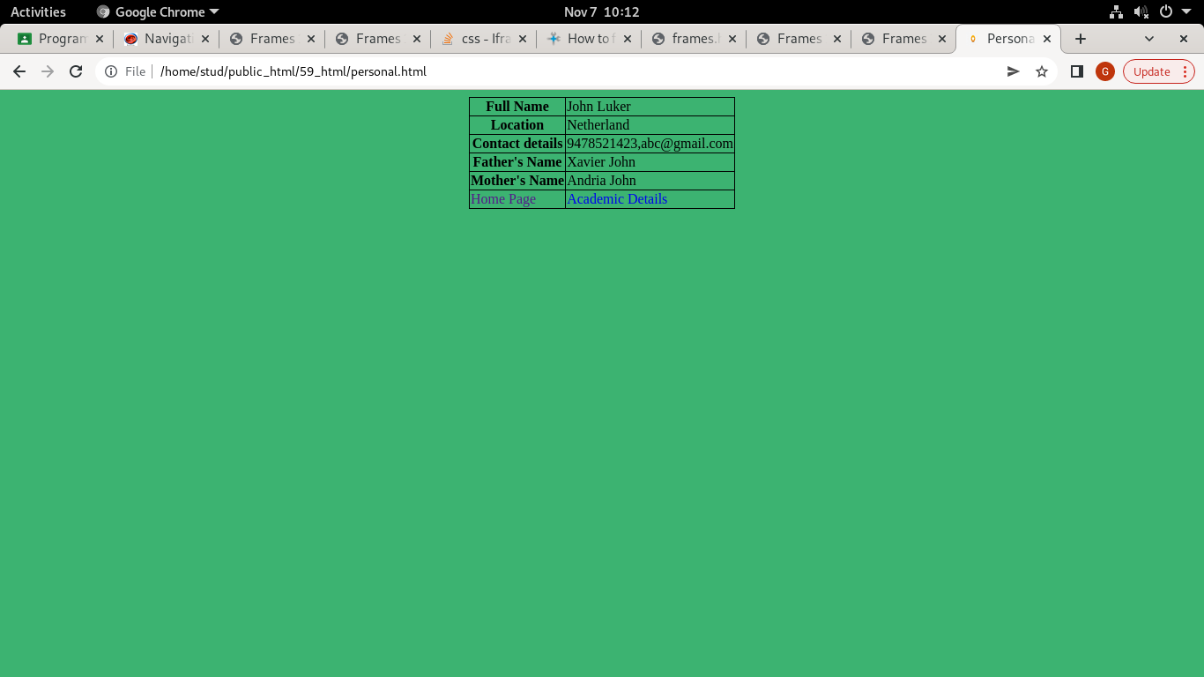

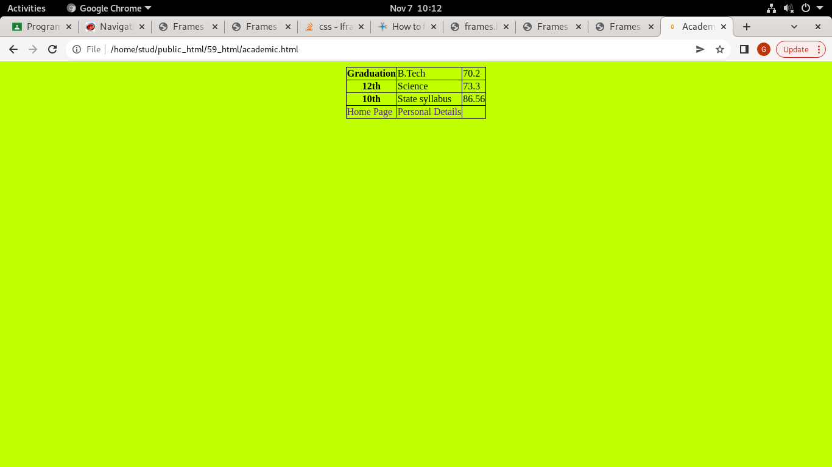

**Aim**

To write a program to design an application form for MCA course in FISAT using HTML.

**Program Code**

<html>

<head>

<title>Application Form | MCA</title>

</head>

<body>

<h1 align="center"><br>FEDERAL INSTITUTE OF SCIENCE AND TECHNOLOGY</h1>

<br><hr><br>

<h2 align="center">MCA Application</h2>

<br>

<form method="POST" action="">

<strong>Name: </strong><input type="text" name="name">

<br><br>

<strong>Address: </strong><textarea name="address" rows="3">Enter Your Address!</textarea>

<br><br>

<strong>Gender: </strong>

<input type="radio" name="gender" value="male">Male

<input type="radio" name="gender" value="female">Female

<input type="radio" name="gender" value="other">Other

<br><br>

<strong>Date Of Birth: </strong><input type="date" name="dob">

<br><br>

<strong>Phone: </strong><input type="number" name="phone">

<br><br>

<strong>E-Mail: </strong><input type="email" name="email">

<br><br>

<strong>Religion: </strong>

<select name="religion">

<option>Select</option>

<option value="Christian">Christian</option>

<option value="Hindu">Hindu</option>

<option value="Muslim">Muslim</option>

<option value="Sikh">Sikh</option>

<option value="Other">Other</option>

</select>

<br><br>

<strong>Caste: </strong><input type="text" name="Caste">

<br><br><hr><br>

<h3>Accademic Details:</h3>

<h3><em>10<sup>th</sup>:</em></h3>

<strong>Name of Institution: </strong><input type="text" name="10thinst">

<br><br>

<strong>Percentage of Marks: </strong><input type="number" name="10thmark">

<br><br>

<h3><em>Plus Two:</em></h3>

<strong>Name of Institution: </strong><input type="text" name="12thinst">

<br><br>

<strong>Percentage of Marks: </strong><input type="number" name="12thmark">

<br><br>

<h3><em>Under Graduate:</em></h3>

<strong>Programme: </strong><input type="text" name="ugp">

<br><br>

<strong>Name of Institution: </strong><input type="text" name="uginst">

<br><br>

<strong>Percentage of Marks: </strong><input type="number" name="ugmark">

<br><br><hr><br>

<input type="submit" name="submit" value="Submit">

<input type="reset" name="reset" value="Reset">

</form>

</body>

</html>

**Output**

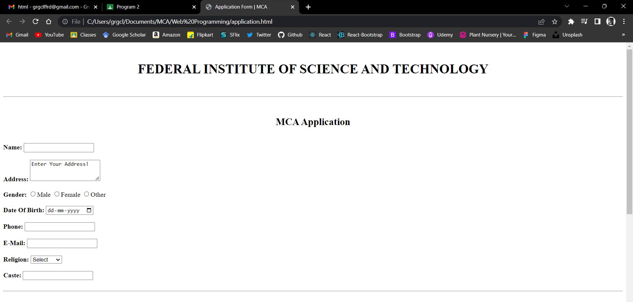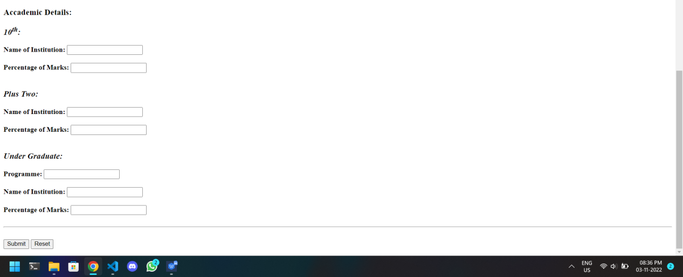

**Aim**

To create a HTML page with different types of frames such as floating frame, navigation frame & mixed frame.

**Program Code**

frame.html:

<html>

<head>

<title>Demonstration of Frames</title>

</head>

<frameset rows="10%,*">

<frame name="header" src="head.html">

<frameset cols="10%,*">

<frame name="nav" src="nav.html">

<frame name="body" src="home.html">

</frameset>

</frameset>

</html>

head.html:

<html>

<head>

<title>Header</title>

</head>

<body bgcolor="grey">

<h2 align="center"><font color="white">Frame Demonstration</font></h2>

</body>

</html>

nav.html:

<html>

<head>

<title>Navbar</title>

</head>

<body bgcolor="grey" align="center">

<font color="white">

<br><br><a href="home.html" target="body"><font color="white">Home</font></a>

<br><br><a href="contents.html" target="body"><font color="white">Contents</font></a>

<br><br><a href="about.html" target="body"><font color="white">About Us</font></a>

</body>

</html>

home.html:

<html>

<head>

<title>Home</title>

</head>

<body>

<h3 align="center"><br>Welcome To The Home Page<br></h3>

<p>This is the first sub-frame!</p>

<br><br><iframe src="float.html" height="50%" width="50%"></iframe>

</body>

</html>

contents.html:

<html>

<head>

<title>Contents</title>

</head>

<body>

<h3 align="center"><br>Contents<br></h3>

<p>This is the second sub-frame!</p>

</body>

</html>

about.html:

<html>

<head>

<title>About Us</title>

</head>

<body>

<h3 align="center"><br>About Us<br></h3>

<p>This is the third sub-frame!</p>

</body>

</html>

float.html

<html>

<head>

<title>Floating Frame</title>

</head>

<body>

<h3 align="center"><br>Floating Frame<br></h3>

<p>This is a floating frame!</p>

</body>

</html>

**Output**

Home Frame:

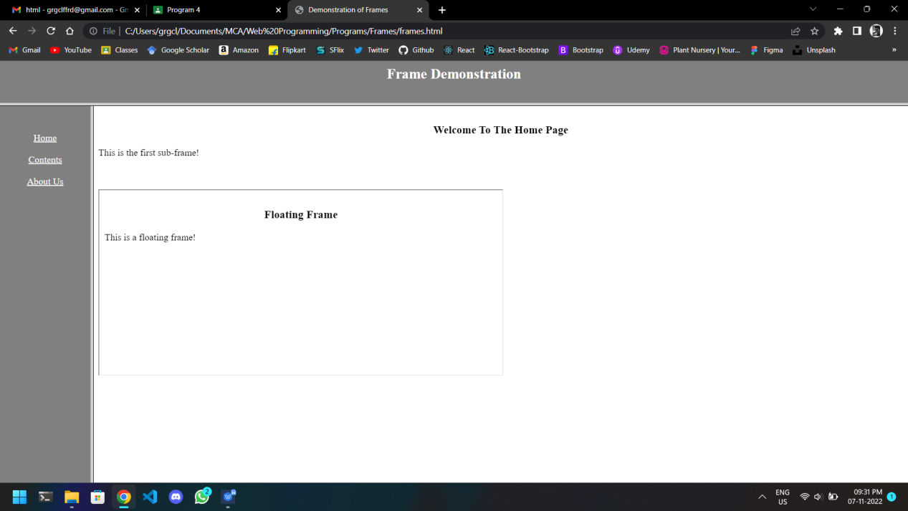

Contents Frame:

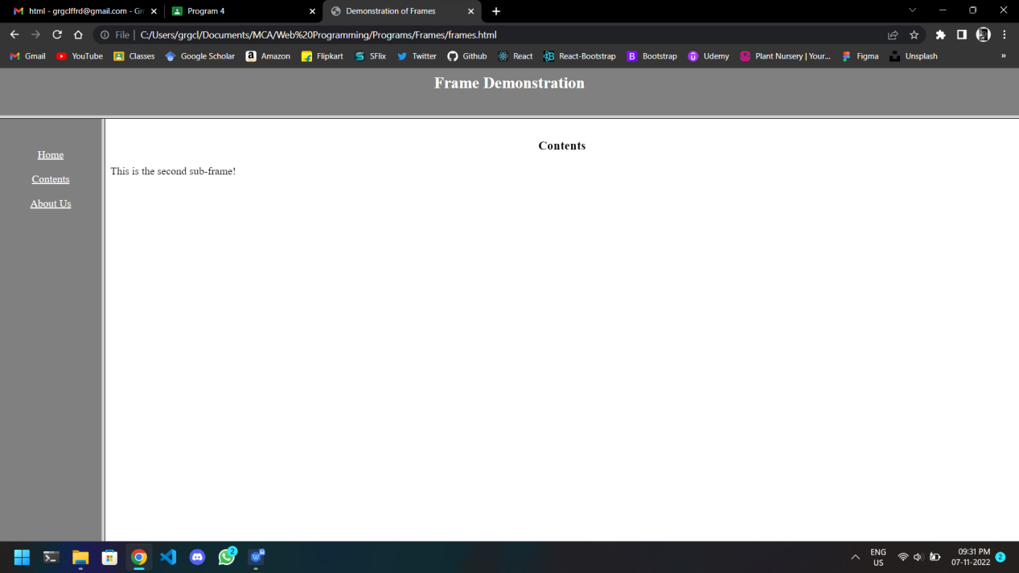

About Us Frame:

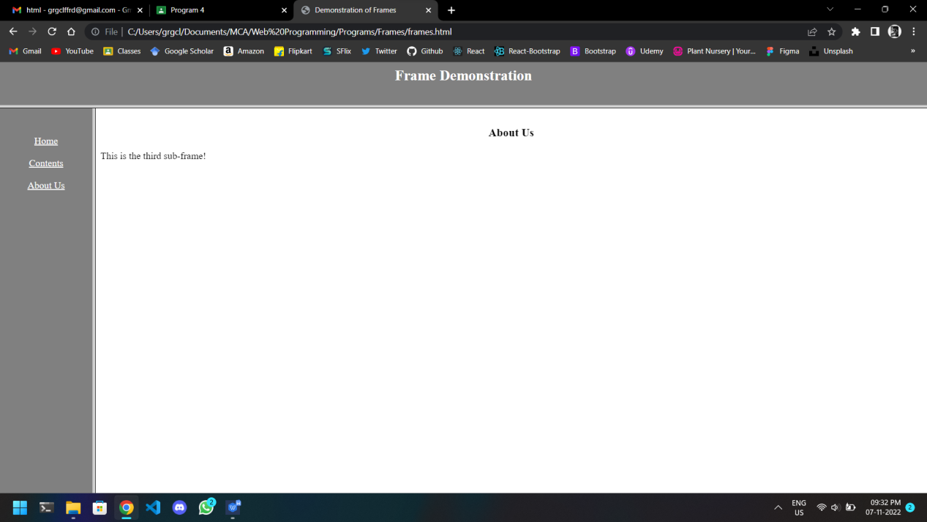

**Aim**

To analyze CSS by applying the different styles using inline, external & internal style sheets in a HTML file.

**Program Code**

**Frame.html**

<html>

<head>

<title>Demonstration of CSS</title>

</head>

<frameset rows="10%,*">

<frame name="header" src="head.html">

<frameset cols="10%,*">

<frame name="nav" src="navi.html">

<frame name="body" src="home.html">

</frameset>

</frameset>

</html>

**Mystyle.css**

body {

background-color: lightblue;

}

h3 {

color: navy;

margin-left: 20px;

text-align: center;

}

p {

color: #ff3399;

margin-left: 40px;

padding-top:20px;

}

**Inline.html**

<html>

<head>

<title>inline css</title>

</head>

<body>

<h3 style="color:blue;text-align:center;"><br>Contents<br></h3>

<p style="color:red;text-align:right;padding-right:150px;">This is the inline CSS</p>

</body>

</html>

**Internal.css**

<html>

<head>

<title>internal css</title>

<style>

body {

background-color: linen;

}

h3 {

color: maroon;

margin-left: 40px;

text-align: center;

}

p {

color: #00e600;

margin-left: 70px;

}

</style>

</head>

<body>

<h3><br>About Us<br></h3>

<p>This is the Internal CSS</p>

</body>

</html>

**External.html**

<html>

<head>

<title>Home</title>

<link rel="stylesheet" href="mystyle.css">

</head>

<body>

<h3><br>Welcome To The Home Page<br></h3>

<p>This is the External CSS</p>

<br><br><iframe src="https://www.geeksforgeeks.org" height="50%" width="50%"></iframe>

</body>

</html>

**Output**

Inline CSS:

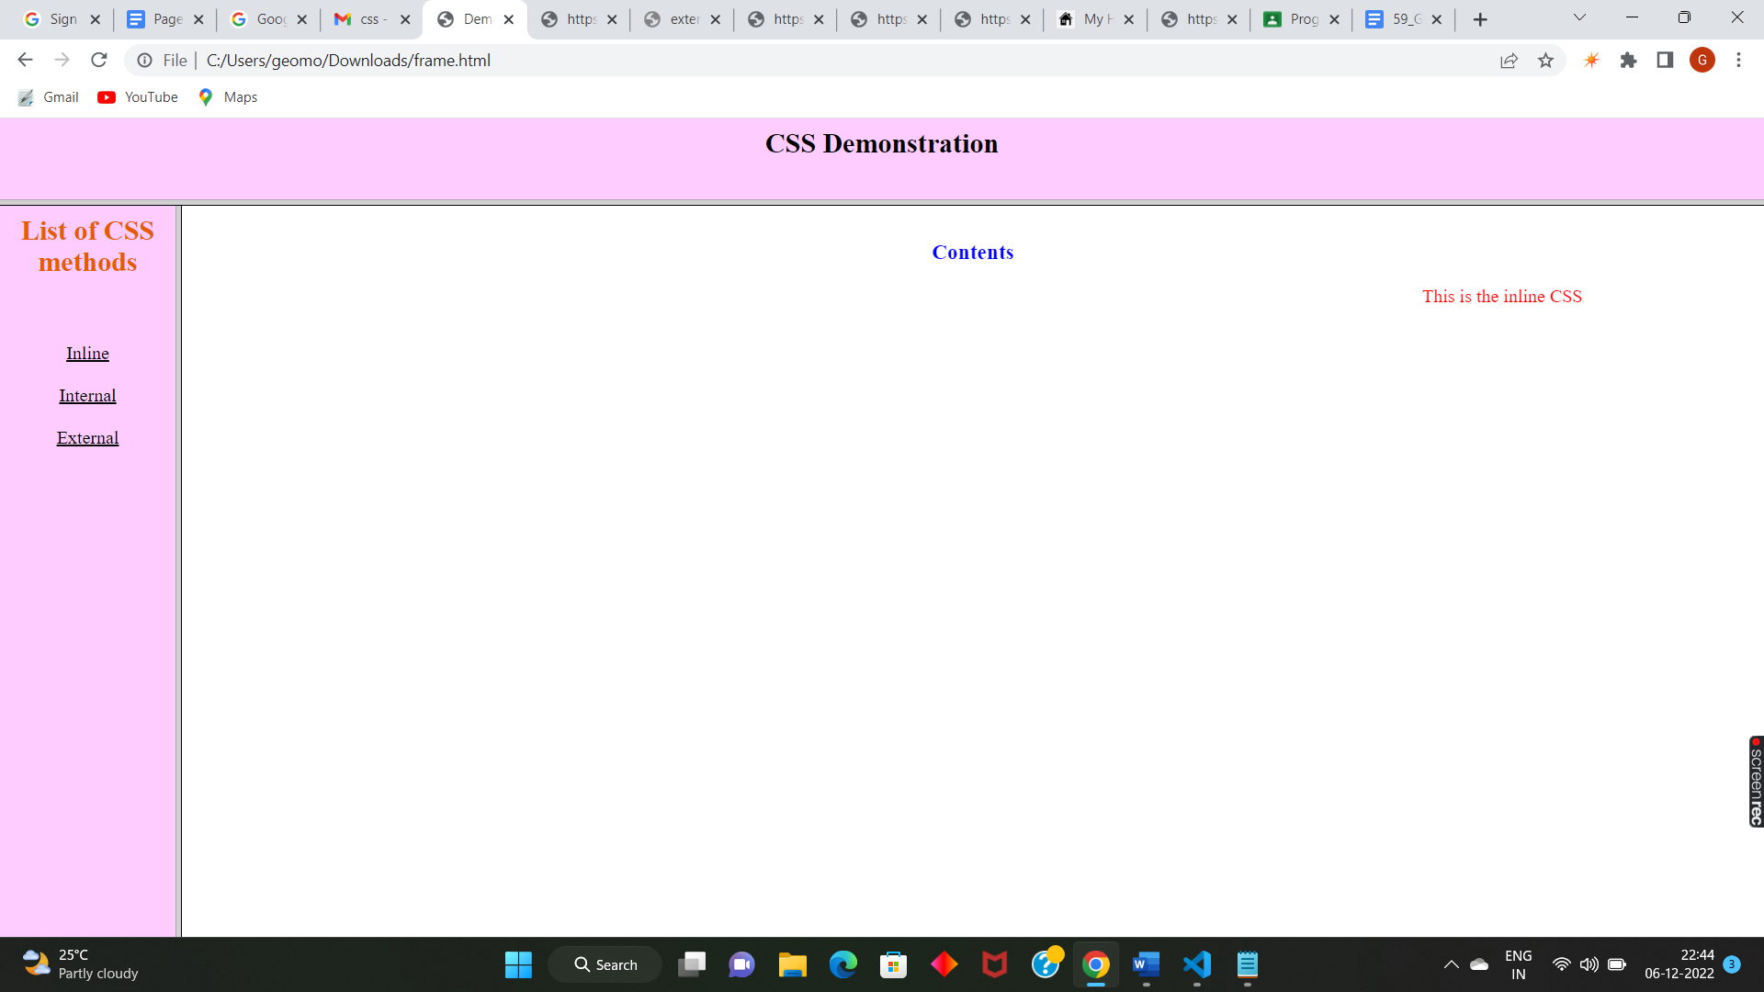

Internal CSS:

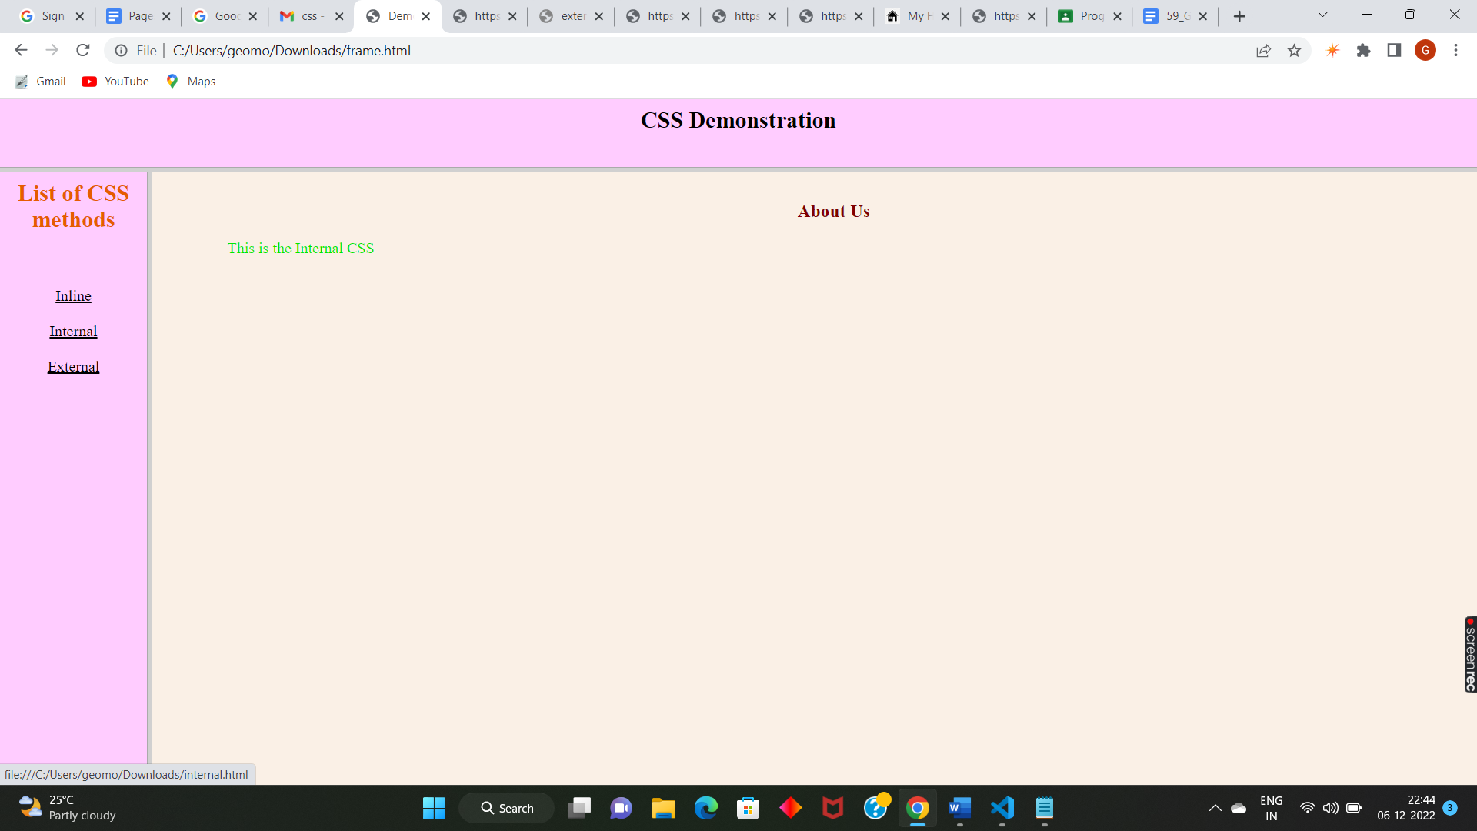

External CSS:

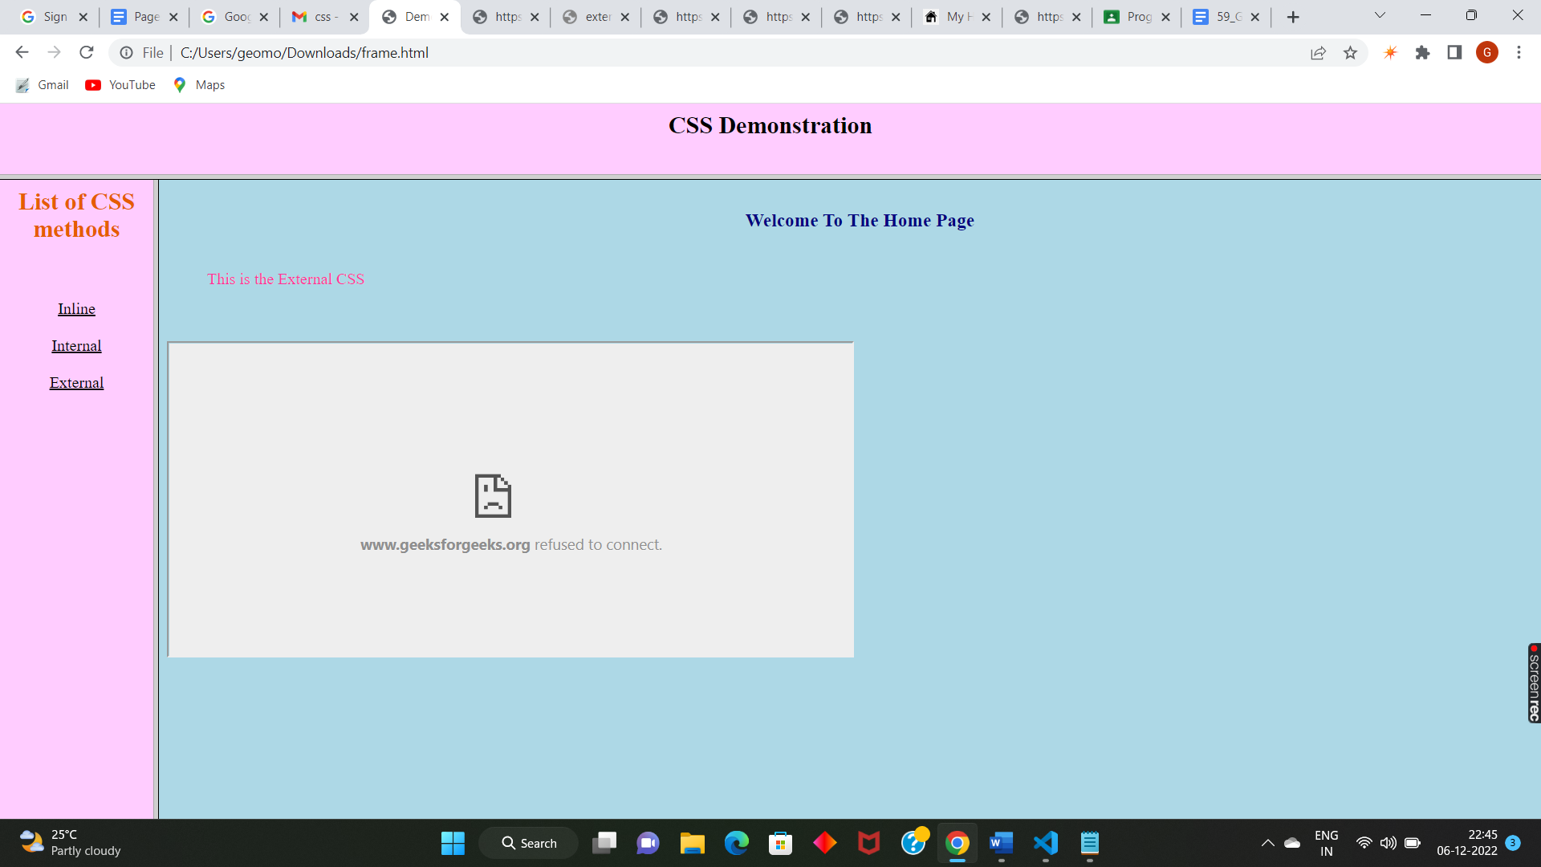

**Aim**

To create a HTML registration form and validate the form using JavaScript code.

**Program Code**

<html>

<head>

<title>Application Form</title>

<script>

function validateForm()

{

var name=document.forms["appform"]["name"].value;

if(name=="")

{

alert("Please Fill Out Your Name!");

return false;

}

var address=document.forms["appform"]["address"].value;

if(address=="")

{

alert("Please Fill Out Your Address!");

return false;

}

var gender=document.forms["appform"]["gender"].value;

if(gender=="")

{

alert("Please Enter Your Gender!");

return false; }

var age=document.forms["appform"]["age"].value;

if(age=="")

{

document.getElementById("ag").innerHTML="Please Enter Your Age!";

return false;

}

else if (isNaN(age))

{

document.getElementById("ag").innerHTML="Please Enter Numeric Values!";

return false;

}

var phone=document.forms["appform"]["phone"].value;

if(phone=="")

{

document.getElementById("ph").innerHTML="Please Enter Your Phone Number!";

return false;

}

else if (isNaN(phone))

{

document.getElementById("ph").innerHTML="Please Enter Numeric Values!";

return false;

}

else if (phone.toString().length!==10)

{

document.getElementById("ph").innerHTML="Please Enter A 10 Digit Phone Number!";

return false;

}

}

</script>

</head>

<body>

<br>

<h2 align="center">Application Form</h2>

<br>

<form name="appform" method="post" action="" onsubmit="return validateForm()">

<strong>Name: </strong><input type="text" name="name">

<br><br>

<strong>Address: </strong><input type="text" name="address">

<br><br>

<strong>Gender: </strong><input type="text" name="gender">

<br><br>

<strong>Age: </strong><input type="text" name="age"><span id="ag"></span>

<br><br>

<strong>Phone: </strong><input type="text" name="phone"><span id="ph"></span>

<br><br>

<input type="submit" name="submit" value="Submit">

<input type="reset" name="reset" value="Reset">

</form>

</body>

</html>

**Output**

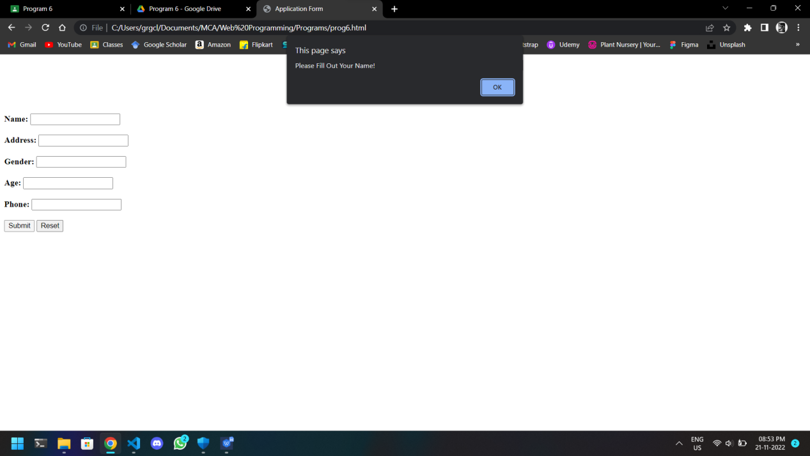

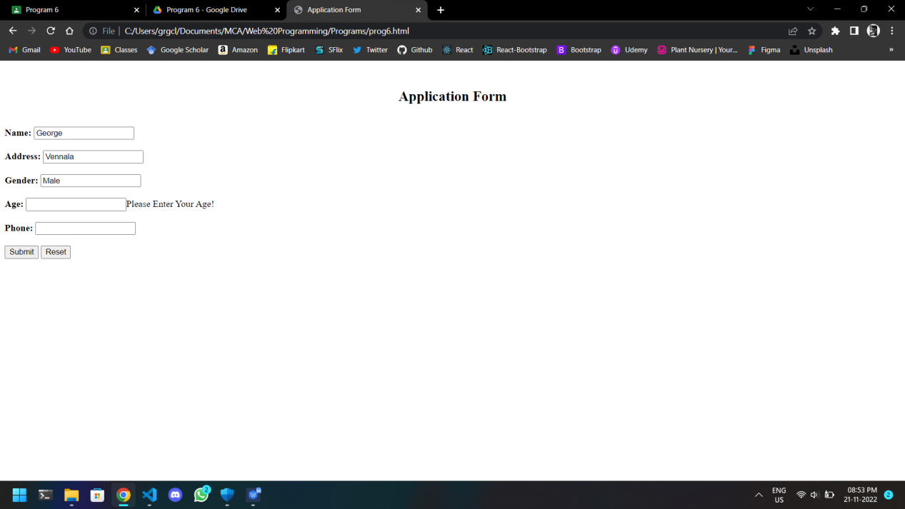

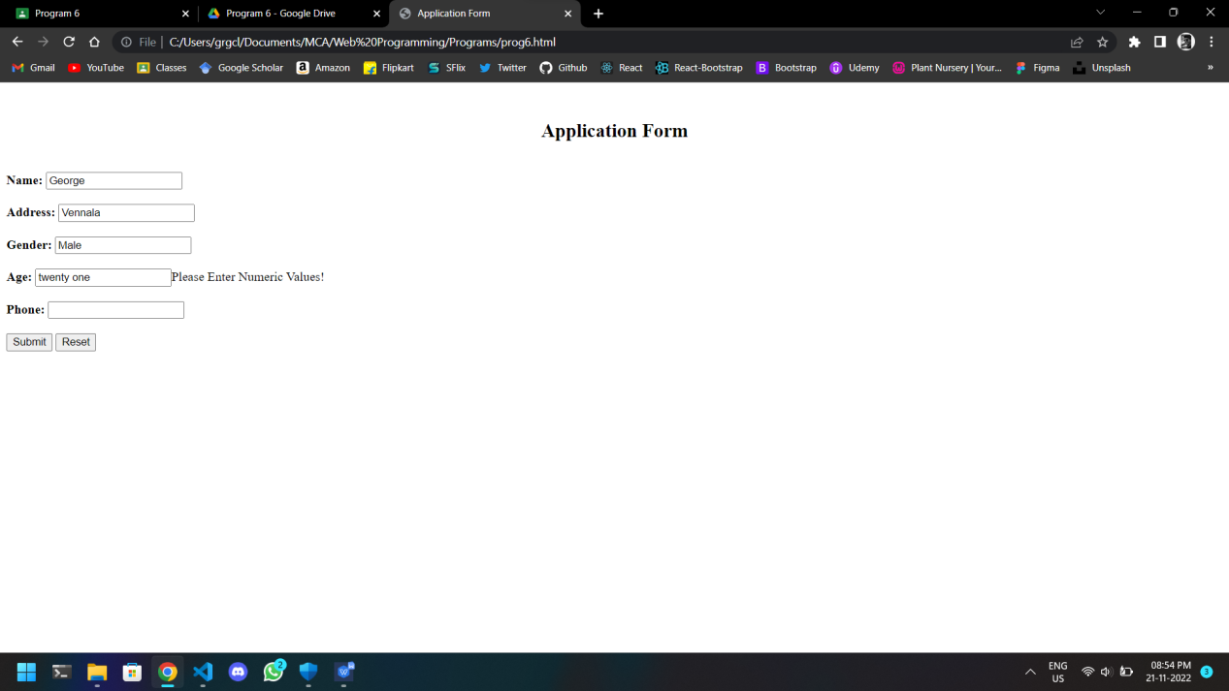

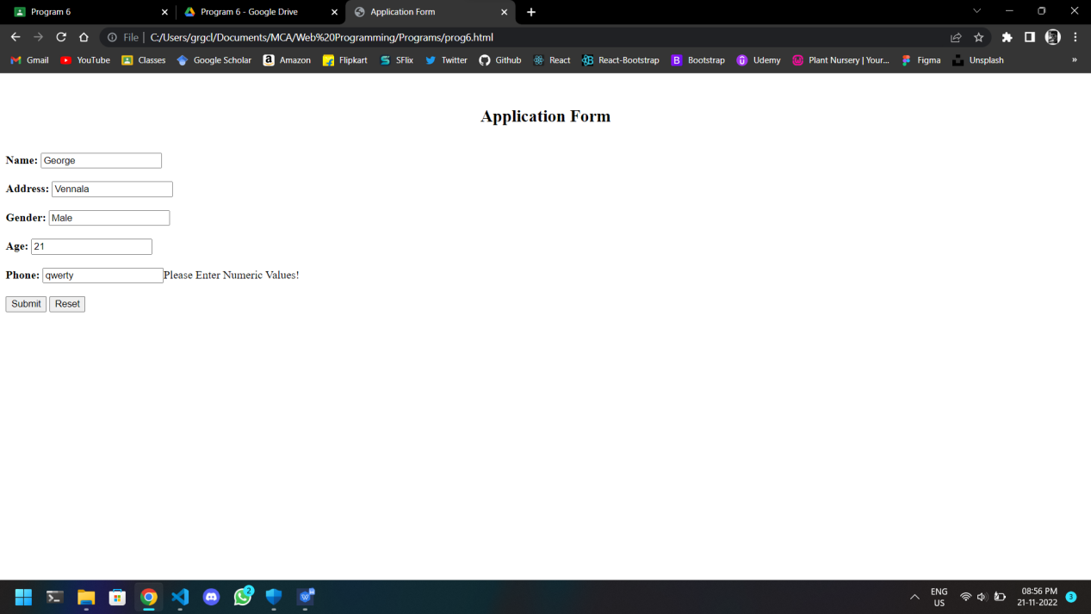

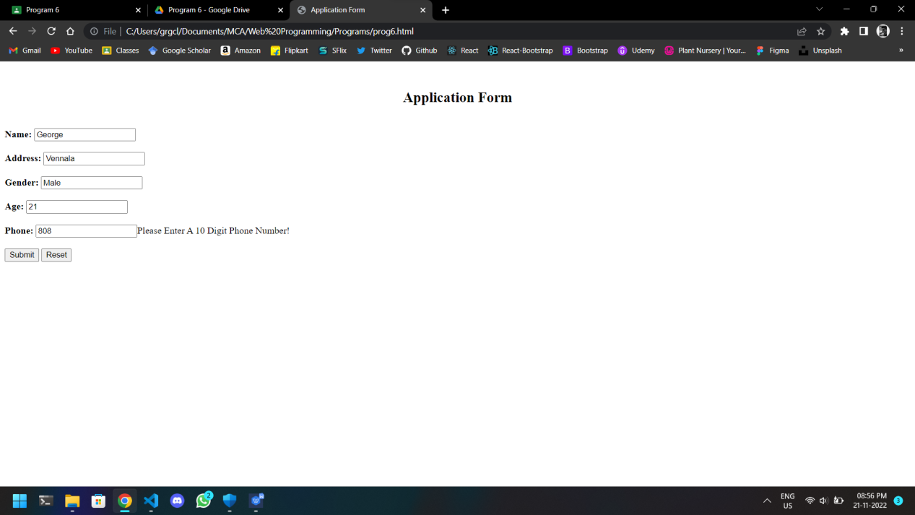

**Aim**

To create a HTML page to explain the use of various predefined functions in a string and math object in java script.

**Program Code**

<html>

<head>

<title>String Methods And Math Objects</title>

</head>

<body>

<br>

<h2>Demonstration Of String Methods And Math Objects Using Javascript.</h2>

<br>

<form name="demoform" method="post" onsubmit="return formfunc()">

<strong>Enter A String: </strong><input type="text" name="string">

<br><br>

<strong>Select A String Method: </strong>

<select name="strselect">

<option selected disabled>Select</option>

<option value="length">Length</option>

<option value="substring">Substring</option>

<option value="replace">Replace</option>

<option value="upper">To Upper Case</option>

<option value="concat">Concatenate</option>

<option value="trim">Trim</option>

<option value="padding">Padding At Start</option>

<option value="char">First Character Code</option>

<option value="split">Split</option>

</select>

<span id="stroutput"></span>

<br><br>

<strong>Select A Math Object: </strong>

<select name="mathselect">

<option selected disabled>Select</option>

<option value="e">Math.E</option>

<option value="pi">Math.PI</option>

<option value="sqrt2">Math.SQRT2</option>

<option value="sqrt1_2">Math.SQRT1_2</option>

<option value="ln2">Math.LN2</option>

<option value="ln10">Math.LN10</option>

<option value="log2e">Math.LOG2E</option>

<option value="log10e">Math.LOG10E</option>

</select>

<span id="mathoutput"></span>

<br><br>

<input type="submit" name="submit" value="Submit">

<input type="reset" name="reset" value="Reset">

</form>

<script>

function formfunc()

{

var text=document.forms["demoform"]["string"].value;

var strop=document.forms["demoform"]["strselect"].value;

if(strop=="length")

{

document.getElementById("stroutput").innerHTML="<p><b>Length of the string:</b> "+text.length+"</p>";

}

else if(strop=="substring")

{

document.getElementById("stroutput").innerHTML="<p><b>Substring of the string from position 3 to 6:</b> "+text.substring(2,5)+"</p>";

}

else if(strop=="replace")

{

document.getElementById("stroutput").innerHTML="<p><b>The string after replacing its first four charachters with 'FOUR':</b> "+text.replace(text.substring(0,4),"FOUR")+"</p>";

}

else if(strop=="upper")

{

document.getElementById("stroutput").innerHTML="<p><b>The string after converting it into upper case:</b> "+text.toUpperCase()+"</p>";

}

else if(strop=="concat")

{

document.getElementById("stroutput").innerHTML="<p><b>The string after concatenation:</b> "+text.concat(" ","Concatenated")+"</p>";

}

else if(strop=="trim")

{

document.getElementById("stroutput").innerHTML="<p><b>The string after trimming:</b> "+text.trim()+"</p>";

}

else if(strop=="padding")

{

document.getElementById("stroutput").innerHTML="<p><b>The string after padding at the beginning:</b> "+text.padStart(5,"0")+"</p>";

}

else if(strop=="char")

{

document.getElementById("stroutput").innerHTML="<p><b>The character code of the first letter of the string:</b> "+text.charCodeAt(0)+"</p>";

}

else if(strop=="split")

{

document.getElementById("stroutput").innerHTML="<p><b>The string after splitting:</b> "+text.split(" ")+"</p>";

}

else

{

document.getElementById("stroutput").innerHTML="Please select a string method!";

}

var mathop=document.forms["demoform"]["mathselect"].value;

if(mathop=="e")

{

document.getElementById("mathoutput").innerHTML="<p><b>Math.E:</b> "+Math.E+"</p>";

return false;

}

else if(mathop=="pi")

{

document.getElementById("mathoutput").innerHTML="<p><b>Math.PI:</b> " + Math.PI + "</p>";

return false;

}

else if(mathop=="sqrt2")

{

document.getElementById("mathoutput").innerHTML="<p><b>Math.SQRT2:</b> " + Math.SQRT2 + "</p>";

return false;

}

else if(mathop=="sqrt1_2")

{

document.getElementById("mathoutput").innerHTML="<p><b>Math.SQRT1_2:</b> " + Math.SQRT1_2 + "</p>";

return false;

}

else if(mathop=="ln2")

{

document.getElementById("mathoutput").innerHTML="<p><b>Math.LN2:</b> " + Math.LN2 + "</p>";

return false;

}

else if(mathop=="ln10")

{

document.getElementById("mathoutput").innerHTML="<p><b>Math.LN10:</b> " + Math.LN10 + "</p>";

return false;

}

else if(mathop=="log2e")

{

document.getElementById("mathoutput").innerHTML="<p><b>Math.LOG2E:</b> " + Math.LOG2E + "</p>";

return false;

}

else if(mathop=="log10e")

{

document.getElementById("mathoutput").innerHTML="<p><b>Math.LOG10E:</b> " + Math.LOG10E + "</p>";

return false;

}

else

{

document.getElementById("mathoutput").innerHTML="Please select a math object!";

return false;

}

}

</script>

</body>

</html>

**Output**

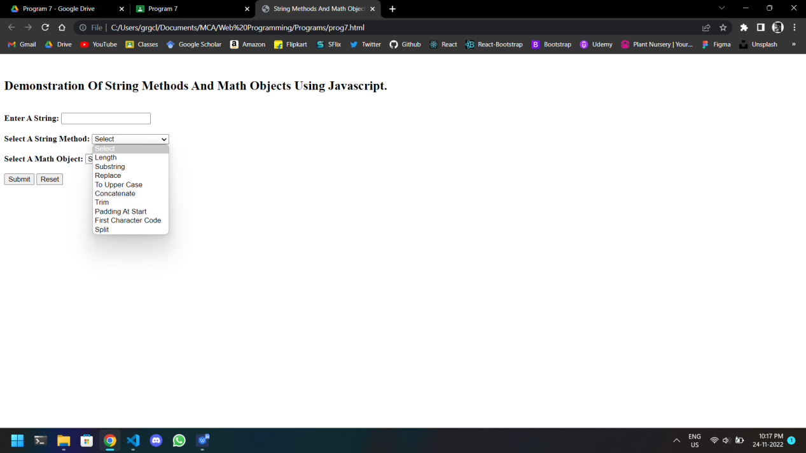

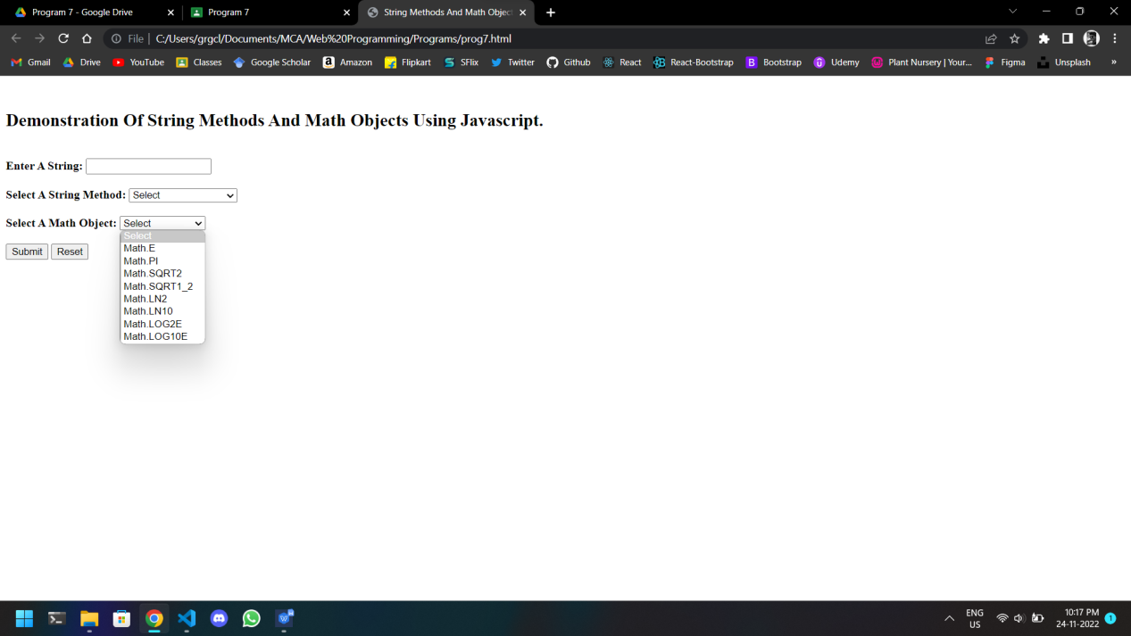

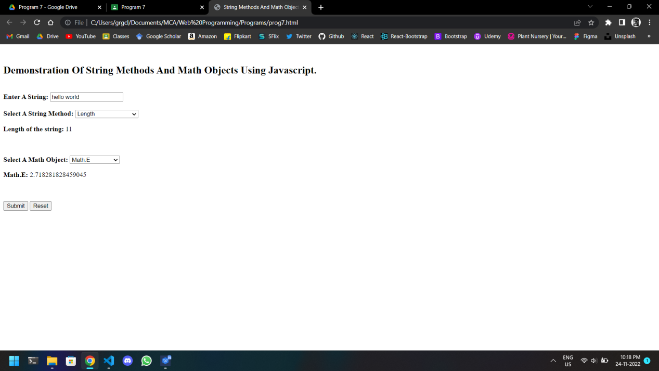

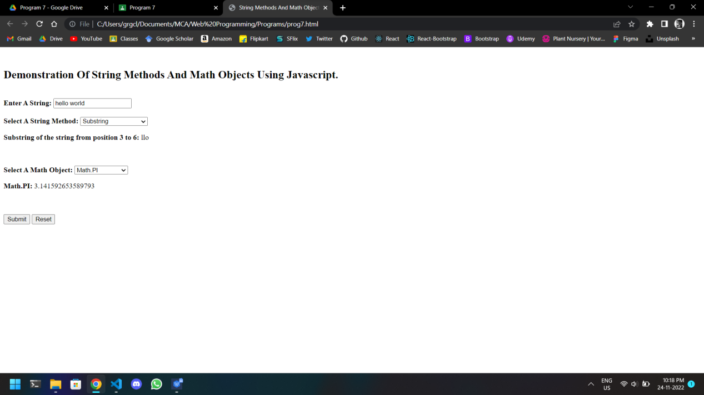

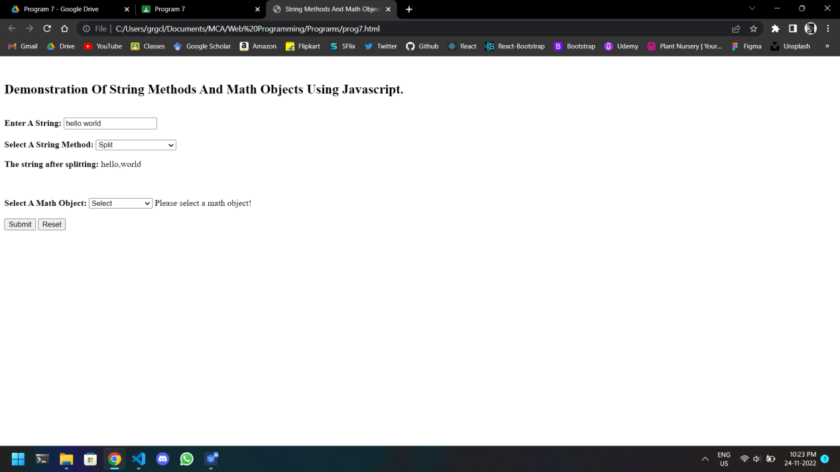

**Aim**

To create a HTML page to change the background color for every click of a button using JavaScript Event Handling.

**Program Code**

<html>

<head>

<title>Changing The Background Color</title>

</head>

<body>

<h1>Using Javascript To Change The Background Colour.</h1>

<button type="button" onclick="change()">Change Background Colour</button>

<br><br>

<script>

document.writeln("Click on the button to change the background colour.");

const body=document.querySelector("body");

function change()

{

let color='#'+(Math.random()*0xFFFFFF<<0).toString(16);

body.style.background=color;

}

</script>

</body>

</html>

**Output**

